From big data to small-scale decisions: what is the impact?

Context and problem: Most technical support services provide farmers with a one size fits all technological package for their particular recommendation domain. Variation in time and space is not taken into account. One of the possible application of big data (BD) is the exploration of existing data to deliver technical messages for farmers that are tailored to the particular conditions of a specific farm at a given moment in time (Cock et. al 2011; Jimenez et al., 2011). In this process data has to be collected, compiled, analyzed and interpreted and then be presented to farmers in an relevant way so that they can use it to make better decisions. A major strength of BD information (BDI) is that it is largely based on farmers' experiences. Paradoxically, this is also its greatest potential weakness. Indeed, most of the data arrives "disembodied" and farmers are unlikely to be able to make sense of it. Thus, the data needs to be processed so that farmers can see how changes in their management practices interact with variations in the weather, whence they can evaluate distinct management strategies under a range of climatic scenarios.
As Climate Change (CC) increases seasonal and inter-annual variability beyond the range farmers are accustomed to (Delerce et al., 2016) the validity of farmers’ tacit knowledge (empirical or intuitive form of knowledge) will be challenged: BDI can play a key role in supporting farmers in their strategies to cope with CC with information taking into account a greater range of environmental conditions and management than that encompassed within their own experience. Colombian national federation of rice growers (Fedearroz) routinely collects rice production and management data from farmers' fields. In partnership with CIAT, Fedearroz has increased both their capacity to collect and to analyze data with BD methods and produce information on how weather variation impacts yield (Delerce et al., 2016). Currently there is no strategy to disseminate BDI directly to farmers and hence farmers do no use BDI for their decision making.
Solutions or new idea: The idea is to design, test and evaluate the impact of different mechanisms (traditional, interactive dialogue mechanisms with farmers) to share BDI with farmers in yields. To do that, first BDI will be processed to throw light on the most relevant practices for rice producers in Casanare department (Colombia) and shared with them through various mechanisms. Then mixed methods (quantitative and qualitative) will be applied to understand (1) the impact of BDI on yield compared with farmers who don’t receive BDI and (2) catalyzers ( social characteristics, perceptions, type of BDI, diffusion mechanisms) that allow farmers to access and make better use of BDI . The lessons learned will provide guidelines for others to develop BD based information systems that empower farmer’s management strategies.
Justification: The production of relevant and quality BDI is not enough to achieve its use by farmers. There is a need to understand if and how farmers can access and use BDI to support decision making at individual and local level (Berman, 2013). Understanding the relative role of BDI in farmers’ decision making constitutes a complex challenge as farmers’ decision-making is fostered and/or constrained by various factors including access to resources and information, experiences, interactions, norms and interests. For this reason, a mixed method combining quantitative and qualitative approaches for the evaluation of the applicability of BD provides a greater and more holistic understanding of a complex situation (Adato; 2008). Indeed, it allows for “triangulation which is better suited to capture complex results” and to share lessons with different actors (researcher, advisory services, peers) (UNDP, 2013).
Thus, the qualitative approach will provide knowledge on empowerment process regarding the use of BDI in decision making. Anthropological methods such as participative observation, interviews and workshops will be used to understand how BDI shared through different mechanisms fits into farmers’ individual and collective knowledge system and in what extent it is used. For the quantitative analysis will be used Randomized Controlled Trials (RCT) and mediation analysis through a factorial design. RCT will evaluate the impact of BDI on yields (Gertler et al., 2016). Then, mediation analysis provide an understanding of the causes of impact or the pathway towards impact (Gerber and Green, 2012). In the trial, different groups will be defined according to specific mechanisms used for sharing BDI. At the end, recommendations will be formulated on how to foster the use of BDI through adapted dialogue mechanisms.
Hypothesis:
1. Farmers’ socio economic profiles (men/women, young/old, big or small-scale farmers…) influence the type of information needed to make technical decisions and the BDI design and diffusion.
2. Interactive dialogue mechanisms induce change in mediating variables (the use by farmers of relevant practices identified through BD analysis) that permit to improve yields.

Theory of Change, information produced and budget:
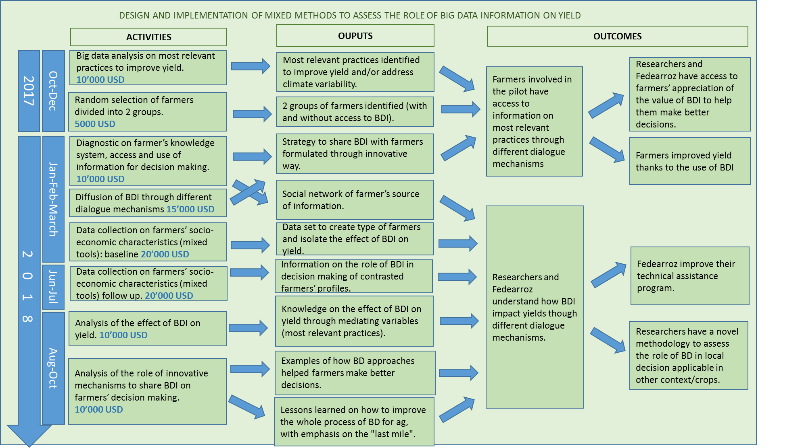

If the pilot is a success the methodology could be applied at a bigger scope (rice in all Colombia), or at other crops (maize) or at other part of the world (Africa, Asia).

Literature:
Adato, M. (2008). Integrating survey and ethnographic methods to evaluate conditional cash transfer programs (Vol. 810). Intl Food Policy Res Inst.
Berman, J. J. (2013). Principles of big data: preparing, sharing, and analyzing complex information. Newnes.
Cock, J., (2011). https://doi.org/10.1016/j.agsy.2011.07.001
Delerce S., et al. (2016) doi.org/10.1371/journal.pone.0161620
Gerber, A., Green, D., (2012). Field Experiments: Design, Analysis and Interpretation. W.W. Norton & Company. Chapter 10. Mediation.
Gertler, P. J., et al. (2016). doi.org/10.1596/978-0-8213-8541-8
Howland, F., et al. (2015). Data sharing and use of ICTs in agriculture: working with small farmer groups in Colombia. Knowledge Management for Development Journal 11(2): 44-63
Jiménez, D., et al. (2011). DOI: 10.1016/j.agsy.2010.10.004 · Source: RePEc
Somers, S., Stapleton, L., (2012). doi.org/10.3182/20120611-3-IE-4029.00020
UNDP, (2013). Discussion paper; Innovations in Monitoring & Evaluation.

