REA³D (Read Agriculture Activity from Above Daily)
Data driven agriculture is frequently presented as the next disrupting technology that will help farmers to improve their yields and income all around the world. But in fact, many agricultural regions of the world are still “data deserts” where little to no data are available. Also, it is complicated to get standardized and up to date data from the farmers. In the developed world, farmers are busy and do not want to spend time on their phone to enter observational data. Meanwhile in the developing world farmers often lack education or training and/or are not used to spend time on the smartphone. Information services that do not require input data from the user, or where input is provided effortlessly have shown to be much easier adopted by the end users. Yet, data are fundamental for data-driven agriculture.
The challenge we are facing is therefore to be able to generate data to monitor agricultural activity where there is no data, or without requiring farmers’ time, and to make sense of it to be able to deliver personalized information to the farmers with a very minimum input data required from their part.
We propose to build on the achievements of the Sen-2-Agri project and push further engaging with high resolution high frequency imagery (3m resolution and daily images) provided by our partner Planet Labs to “read” crop phenological stage for rice from above in real-time at both regional and field level.
The tool should detect field boundaries, determine if rice is being grown, inform on the growth stage and the crop status (green index, level of homogeneity in the field). The data retrieved from the satellite will then be related to historical weather data to determine weather-crop stage relationships. Finally, the crop observation platform will be coupled to 1–10 day weather forecasts from IDEAM (Colombian Met. Service) to test early warnings on drought risk (e.g. at planting, during grain filling), harvest delays, risks of lodging or rice blast outbreaks in the rice crops.

Our aim is to develop an automated early warning system for near future crop status by combining weather forecasts together with current and historical remote sensing observations. This will be achieved by overpassing the bottleneck of data availability through the large dataset provided by Planet Labs. The service proposed to the farmers will be available with little to no work needed from them and will be disseminated through Fedearroz communication channels.
The products of the projects will have several users’ profiles:
- Individual farmers interested in the monitoring tool and early warnings for their own farm.
- Agricultural organizations, public administration for regional-scale monitoring and real-time census data.
- Insurances, information providers (e.g. SpaceKnow) and other private companies in need of updated agricultural data for modelling purposes.
This idea has high probability of success because:
- It builds on earlier achievements (Sen-2-agri).
- It builds on the achievements of CIAT and Fedearroz agro-climatology team in climate prediction, and IDEAM’s weather forecasts.
- Fedearroz has the capacity to provide a lot of ground-truth data (historic and new), and has already started exploratory work with remote sensing (interested).
- Planet Labs provides the state-of-the art high frequency and high resolution satellite imagery
- Strong background in CIAT on remote sensing and computing infrastructure available.
- CIAT already obtained promising experimental results with Sentinel imagery
How will you pilot it?
There is already a good basis of work on weather forecast and historical data collection and preparation. The main piece of work will be on the training and testing of the algorithms that will perform the “reading” of the satellite imagery. This step may involve Deep learning artificial neural network to exploit the full potential of high resolution imagery. We beneficiate from the fact that this main step can start immediately using the historical data with 2017 having shown low cloudiness.
Below is a diagram summarizing the schedule of the different tasks and the distribution of the funding between the partners.
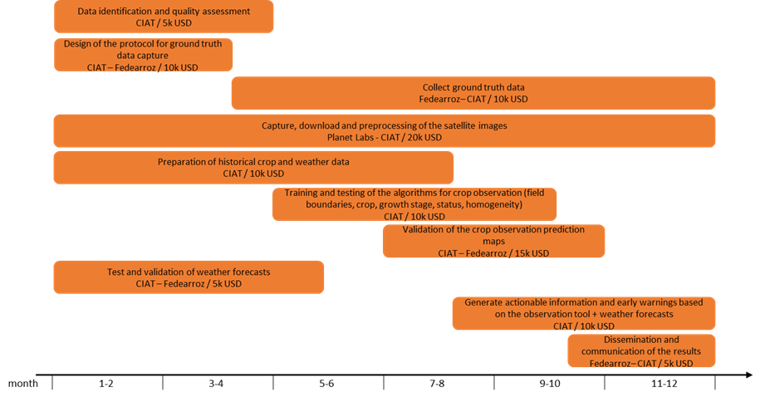
This pilot project is expected to confirm the work hypothesis (i.e. that we can actually “read” agricultural activity from above daily) by releasing open source algorithms capable of extracting the desired variables routinely from the input imagery. The pilot will also generate crop monitoring data from field to regional scale on a daily basis (open-access) that will be compared to the ground truth data that will also be produced and released in open access for further developments.
When the project meets all its goals, the way will be open for massive scale-up in the CGIAR target countries to generate realms of data and unleash data-driven farming. In order to have the tool functioning, local studies will be required to find the appropriate partners, business model (for sustainability) and to make adjustments to local contexts. We anticipate a scaling up in African countries and an exploration of the potential for public-private partnerships with insurances and information providers such as SpaceKnow.

