What is your idea? [Theme: Revealing Food Systems]

The food system, one of the most important drivers of planetary transformation (Rockstrom et al 2009, Ehrlich and Ehrlich 2013), is “in crisis”. There have been multiple failures of the global food system, including unequal distribution of available food resources, leading to problems such as the obesity pandemic (Swinburn et al., 2011), food waste (FAO, 2011), at the same time as malnutrition and hunger; and the focus on agricultural productivity, leading to depletion of natural resources. Therefore, seeking an ecologically sustainable and socially fair transition pathway out of this crisis becomes an issue of utmost priority (Vivero-Pol 2017). Multiple voices have called for a paradigm shift in the structure and operation of the global food system (IAASTD 2009, Watson 2012, Rosin et al. 2012b). The application of systems thinking to understand and manage the complexity of the reality may help to achieve this transformation (Bosch et al. 2007, UNEP 2011). The Economics of Ecosystems and Biodiversity (TEEB) for Agriculture and Food (“TEEBAgriFood”) study, led by the UNEP-TEEB program, sets out to evaluate the reality of today’s highly complex “eco-agri-food” systems (Figure 1).

The ‘eco-agri-food systems’ complex, first proposed in the TEEB for Agriculture & Food Interim Report (TEEB 2015, http://www.teebweb.org/agriculture-and-food/interim-report), is a collective term for the fabric woven from these many system threads, encompassing the vast and interacting complex of ecosystems, agricultural lands, pastures, fisheries, labour, infrastructure, technology, policies, culture, traditions, and institutions (including markets) that are variously involved in growing, processing, distributing and consuming food. The idea of a comprehensive, system-based evaluation framework for the eco-agri-food system emerged in the same interim report and is now being fully developed in the “Scientific and Economic Foundations” report, due to be launched by the end of 2017. In partnership with the Chinese Academy of Agricultural Sciences (CAAS), this project will pilot-test the application of the “eco-agri-food system” evaluation framework developed by the TEEBAgriFood study in China.

Traditionally, scientists have teased apart components or subsystems of the eco-agri-food system for individual studies. However, little attention is paid to connecting the pieces of this jigsaw to achieve a comprehensive understanding of the reality. Indeed, there is no holistic framework that allows to integrate these well-understood jigsaw pieces together into a new, full, picture. Despite evidence of the interconnectedness of our challenges across sectors, the current political and scientific incentive structures do not reward integrated approaches that address linkages and feedback loops, which cut across multiple sectors and disciplines to seek shared solutions. This leads to an increasing number of policies, programs, and strategies designed to address problems based on ‘silo’ solutions. These ignore consequences, trade-offs and impacts across sectors and economic actors far beyond their intended effects, which too frequently work against sustainability. The ambition of the TEEBAgriFood evaluation is to improve the conditions for integrated decision-making. To achieve this, the contributions of natural (ecosystem services and biodiversity) and social capital (e.g., collective action institutions, equal access to resources) to the eco-agri-food system need to be made visible, not just focusing on production processes, but shedding light on multiple interactions, feedback loops, and pathways by which the environment and agriculture contribute to human health and well-being. Focusing on innovative methods of collecting, analyzing, accessing, and using data, as well as interpretation and communication about data knowledge, this project attempts to improve the traditionally silo’ed ways of understanding, describing, and analyzing eco-agri-food systems in China, following the system-based evaluation framework developed by the TEEBAgriFood study.

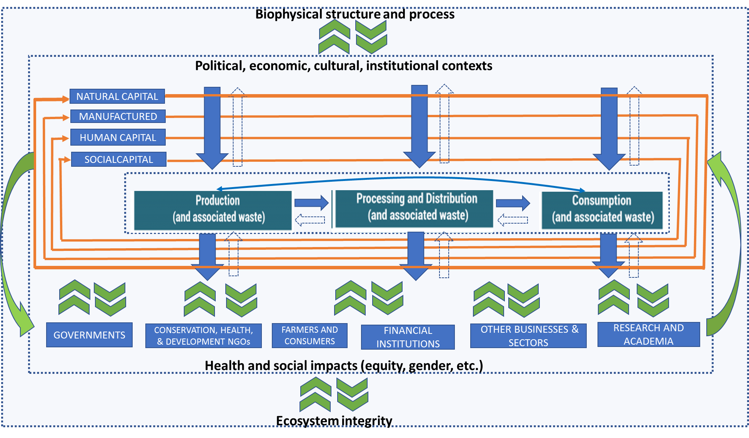

Figure 1: General conceptual framework of the eco-agri-food system (under development)

How will you pilot it?
Building on the vast datasets maintained by CAAS and the extensive, long-term collaborative relationship between IFPRI and CAAS, this project will implement the following activities:

1. explore innovative ways to utilize and integrate the existing vast amount of data collected by various units of CAAS
2. design and implement novel, integrated data collection and analysis methods, as well as coordinated interpretation and communication of data products and knowledge
3. map and evaluate representative eco-agri-food systems in China, using the new systemic, value chain stage-based, holistic evaluation framework developed by the TEEBAgriFood study
4. based on experience from the pilot application, identify and make recommendations on filing data gaps and bridging across sectors, disciplines, and CAAS institutes to integrate data collection, analysis, and utilization of results for improved decision-making regarding the socio-economic and health impacts, as well as the environmental sustainability of representative eco-agri-food systems in China.

