Our idea: to investigate approaches that empower farmers and help them make optimal seasonal and intra-seasonal agricultural decisions and minimize ‘technology failure’ due to unforeseen (but predictable) changes in climatic and weather conditions. We will test whether and how access to an integrated decision support system (IDSS) can help improve the effectiveness and efficiency of agricultural extension systems. We are proposing an innovative idea to test and refine IDSS approaches in Ethiopia with a potential for scaling up/out. The main hypothesis is that the promotion of innovations with a fixed set of management package results in sub-optimal adoption or dis-adoption when the package fails to adjust to the prevailing seasonal climate conditions. Risk averse farmers are less likely to invest in high risk-high return investments and more likely to shift resources away from farming and to non/less productive (more liquid) ventures.
The pilot is expected to succeed because most of the agricultural activities in Ethiopia occur in the highly-populated highlands that are dominated by mixed crop-livestock production systems and are highly sensitive to weather and climate. Smallholders have limited capacity and access to a decision support system that helps them respond to climate variability and extremes, in the context of missing/incomplete markets for credits and other financial products. Access to an IDSS is expected to promote the adoption of innovations that can sustainably improve productivity and development outcomes. In a recent IDSS study in Ethiopia (involving the provision of seasonal and intra-seasonal agro-advisory service on improved crop varieties; agronomic practices, water and disease management, and market information) finds higher productivity and income among IDSS beneficiaries (Tesfaye et al., 2016).

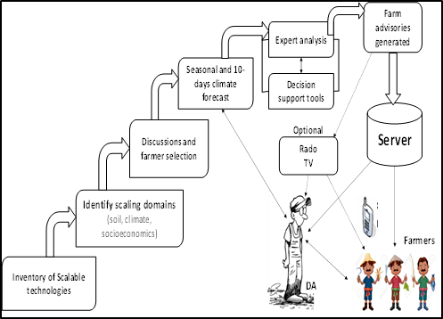
Implementation plan: The first step is inventory of scalable technology packages. During the first phase of Africa RISING program, CGIAR researchers have identified several agroecology-specific CSA practices (e.g., new crop varieties with agronomic management package, new forage seeds with full management package and others) with a potential to sustainably intensify key farming systems in Ethiopia. Next, technology scaling domains will be identified based on biophysical and socioeconomic criteria. Then, beneficiary households (as well as control group) will be randomly selected and discussion will be held about the technologies and the IDSS to be provided throughout the season. This will be followed by seasonal and intra-seasonal weather forecast, where a team of climate scientists will downscale the forecast to the

desired spatial and temporal scale and make it available to farm-advisory developers.
Using the climate forecast, advisory experts will then develop an advisory package using decisions support tools and their expert knowledge. Finally, the farm advisories will be uploaded to a server for beneficiaries to access them through Interactive Voice Response System and SMS in local languages. For beneficiaries without mobile phones, the advisory will be delivered through Development Agents (DAs) stationed in their communities.
IFPRI, CIMMYT, and the Ethiopian Institute of Agricultural Research (EIAR) will participate in this pilot project. CIMMYT will lead climate forecasting, advisory services, and capacity building (farmers and agricultural experts) at different levels. IFPRI will lead the impact evaluation of the pilot project and co-monitoring of the implementation process. EIAR will provide computer server and related ICT facilities; assign climate scientists who will provide regular weather forecast, and experts who develop agro-advisories and upload them onto the IDSS; as well as co-lead the field operations. Activities and timeline are summarized below
Budget and timeline: About 25% of the $100,000 will be used for project monitoring and collection of baseline and follow-up data. 25% will be used to cover the time of one senior researcher and a research assistant at CIMMYT. 30% will cover IDSS-related costs and the time of a field coordinator at EIAR. 20% will cover the time of an IFPRI research fellow responsible for overseeing the impact evaluation. The timeline of activities is summarized below.

Data: Qualitative data will be collected about the implementation of the pilot project, including challenges and opportunities by implementing partners, and perceptions of beneficiaries. Baseline and follow-up quantitative data will be collected about adoption decisions and selected agronomic outcomes. A report, a policy brief and a journal article will be prepared based on the evidence to be generated.
Next steps: Africa RISING program already has several (development) partners, including from the Ministry of Agriculture and Natural Resources and the Ministry of Livestock and Fisheries. Validated IDSS approaches will be shared with these partners for scaling up/out. Implementation guidelines with expected benefits will be prepared for local agricultural bureaus and other development partners who may be interested in scaling. Cases will be made for the most promising IDSS approach for national level adoption through the national agricultural extension system. CGIAR Centers and EIAR directorates will be invited to participate in the identification and packaging of additional- and agroecology-specific innovations that may benefit from IDSS.

