What is your idea?
Big data and small data – a bridge between global data and local action
The idea is unconventional as it adapts and transforms open global soil property data to a form that is actually useful at local scale, for smallholder subsistence farmers to make better decisions on investments in soil inputs, such as lime or fertilizer. We will develop a practical tool to be used in the struggle for filling yield gaps and a more sustainable agricultural production whilst increasing economical and nutritional returns. Policy and recommendations may be regional or national but any actions taken to improve agricultural production are always made locally. Our aim is therefore to provide locally adapted decision support based on user interactivity. The idea is based on similar principles as a national system for Swedish farmers that we recently developed (Markdata – freely available on http://www.markdata.se; 3000 users in 2017). Therefore, the chances to succeed with this project are good. All bits and pieces are there – we just need to adapt and assemble them into a functioning system (the user interface, the algorithms and the global datasets) and test it in reality.

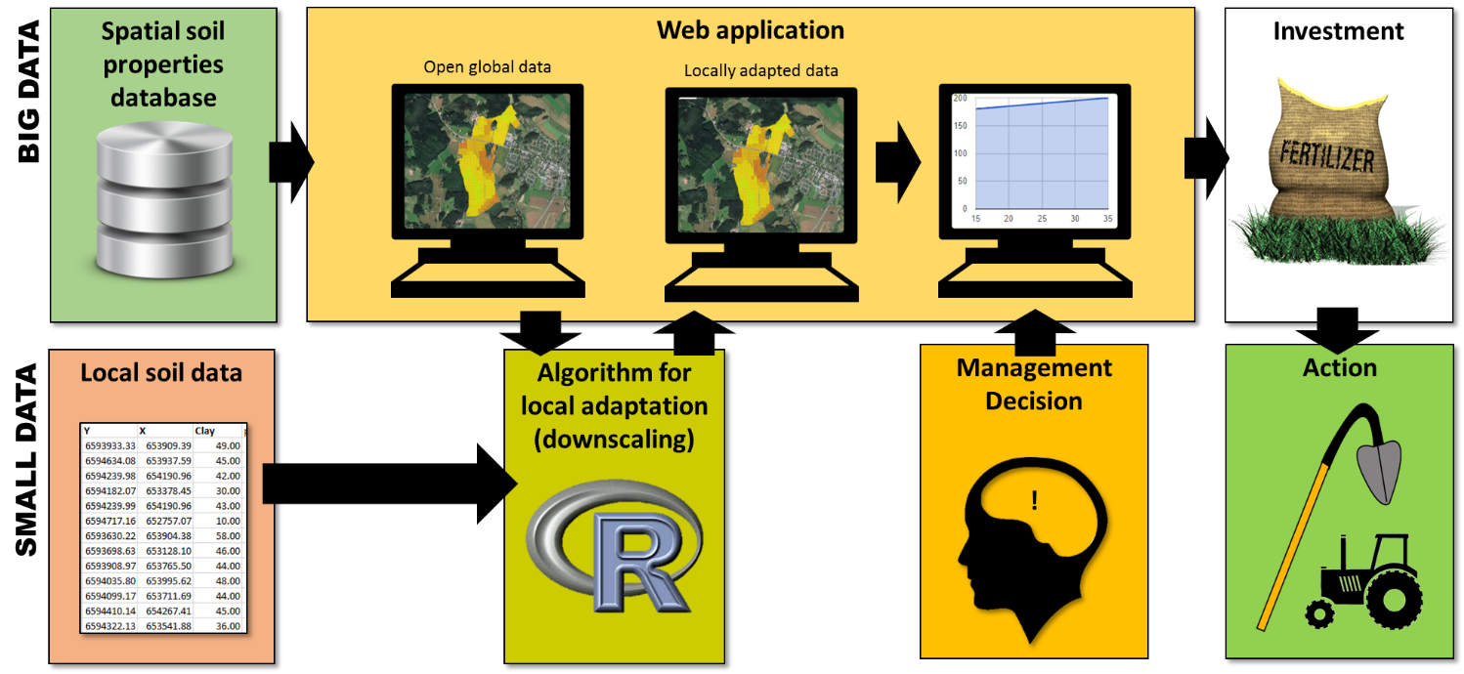

We will mainly work at village level, which is the joint between the farmers and the providers of soil inputs. Villages are also the level where extension officers act. The extension service and local authorities are our main target group. The system will also be useful for the fertilizer industry to be able to sell locally adapted fertilizer blends and appropriate types of lime. With a small set of local samples the user can obtain risk maps over their village, indicating risk of low pH or nutrient deficiencies. These maps are essential tools for guiding farmers to further soil testing or for direct advice on inputs.

How will you pilot it?
Implementation plan
Measurements (30 k USD 3 months, Piikki & Söderström, CIAT/SLU): The interactive system needs small data, i.e. local soil analyses that can be integrated into the system for downscaling of global databases (big data). An alternative to laboratory analyses might be data generated from field test kits and proximal sensors (Piikki et al. 2017a). A guide to the usefulness of these alternatives will be compiled.
Algorithm (10 k USD, 1 month, Piikki & Söderström, CIAT/SLU): We will modify our already developed downscaling algorithm (Maps.R.Interactive; Piikki et al. 2017b) that builds on geostatistical interpolation methods adapted for small datasets (principles described by Söderström et al., 2016; 2017). Maps.R.Interactive fuses the uploaded data with global datasets, and produces a downscaled version of the latter – only for the user. In the pilot system we will focus on soil pH, soil C, exchangeable cation capacity (ECe), plant available nutrients (P, K, Mg, Zn, Cu) and clay content.
User interface (20 k USD, 1 month, programmer, CIAT): The experiences, concept and principles used in the national Markdata application will be used. The user interface is expected to be wizard-like, extremely simple, and adapted for multiple platforms (from PCs to smartphones).
Open database: There are now a number global open soil data products (Soilgrids, S-World, the Global Soil Carbon Map, and more to come). The system will be continuously updated with the latest versions. All data products will be assessed automatically by the system within the user´s area of interest, and the locally most accurate, downscaled map will made available for download (as built into Markdata). This is a unique feature which improves the quality of produced maps (Piikki et al. 2017).
Server solution (20 k USD, 1 month, ICT specialist, CIAT): This part encompasses setting up an appropriate server solution. Running cost for the project period + 3 months will be covered.
Implementation (20 k USD, 4 months, 6 travelling staff, CIAT): Tanzania). Within the 12 months we aim to train 100 extension officers and engage them in a user experience (UX) design process that will ensure that the application is fit for purpose.
What essential data will be generated during this pilot?
The essential part of the system is actually not to produce data, but to provide a tool for downscaling. The system will generate local soil information (such as likelihood for lime requirement, most appropriate fertilizer blend, or need for micronutrients) that can be directly used to guide action. The approach is entirely new. We are attending soil science and pedometrics conferences and workshops yearly and as far as we know Markdata is the only system that actually transforms a general soil database automatically to a useful format through interactive functions; and also provide the user with accuracy measures at the local scale. With an application like this – global databases becomes useful for everyone and can make a difference in the livelihood of people.
What are the next steps?
Our vision is a global system, free to use, in which we take advantage of existing big data and makes them useable. Principally, if the pilot will be successful, there is no reason why it shall not be possible to extend to cover the entire world.

