What is your idea? (for Disrupting Impact Assessment): Impact-Investment Demonstrator
Estimating the efficiency of investment in research & development on societal goals and desired impacts like mal nutrition, hunger, gender inequality, digital divide, social inclusion is complex and no established method exists so far to link research activities and investment in research to end-impacts. In their 2016 PNAS article, Van Ittersum et al. explore the relationship between food self-sufficiency and agricultural productivity, and link potential-to-produce to other indicators, also introducing a thought experimenting on the potential of Sub-Saharan Africa to feed itself by 2050. This idea could be extrapolated and implemented on a much larger scale using Big Data & linked data techniques, linking data sources on societal goals, agricultural productivity, research investments and biophysical characteristics into a Big Data Lake. As argued in Lokers et al (2016), building new applications using big data requires the alignment of multiple data sets in a big data collection, so that the creativity of researchers and innovators can be released for finding new innovative uses of the data.
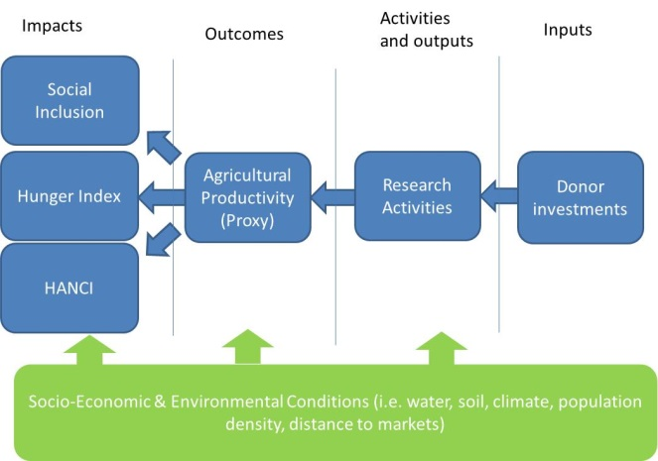
This Inspire project develops an Impact-Investment-demonstrator, that assesses the links between desired end impacts (as mal-nutrition, hunger, gender inequality, social inclusion) and donor investments in research & development using agricultural productivity as an intermediate outcome indicator. The impactInvestment-demonstrator uses with Big Data techniques for analysing links between diverse data sets (capturing the different elements along the impact chain) brought together in a Big Data Lake. The ImpactInvestment demonstrator will be applicable to a wide range of commodities and aims for global coverage, and can thus be used for the different CRP’s part of CGIAR’s research portfolio. The demonstrator will thus lower the costs of Impact Assessment and improve the targeting of donor funding, as it will deliver basic data sets of status of end impacts, donor investment, and agricultural productivity combined with indications of relationships between these variables. The further development of the demonstrator will enable the tracking of the impact of the donor portfolio year-to-year.
Figure 1 Conceptual overview for the approach (causalities are not assumed, just correlations)
The research team consists of Wageningen University and Research and CIMMYT. Wageningen UR has a long track record in systems thinking and linking different systems components, and in recent years has established several big data collections as an accelator to innovation in research and business (see Lokers et al. 2016 & Knapen et al. 2017). CIMMYT has a long track record in agricultural innovations in agricultural systems, and has a thorough understanding of the CGIAR’s impact assessment system.
How will you pilot it?
For the ImpactInvestment demonstrator, three parts need to be build. First, an essential data collection needs to created as a Big Data Lake, that is a reference point for developing future applications (costs: 30k USD; M1-M4). This Big Data Lake entails: 1.) the development a spatial framework that combines farming-system & biophysical (e.g., climate, soil, field sizes) and socio-economic (e.g. population density, distance to markets, per capita income, hunger, nutritional status, etc.) factors; 2.) Extract, Transform & Load data from data from IFPRI Global Hunger Index, IDS Hunger and Nutrition Commitment Index (HANCI), Economist Food Systems Indicator, YieldGap.org (with data & involvement of ICRISAT and CIMMYT), OpenAgFunding initiative, ISRIC’s SoilGrids (Organic Matter, non-response soils) and additional maps (population density, distance to markets, per capita income, hunger, nutritional status), scaling data to the spatial framework and covering all steps in Figure 1 from inputs to impacts; 3.) Installation of the Big Data Lake as an open data resource on Wageningen UR’s Spark/Hadoop cluster and install relevant analysis and visualisation tools, using Open Source components when possible. The majority of the Big Spatial Data will be handled as raster data for high performance processing. Vector data will be added for filtering, selecting and visualisation purposes. A distributed NoSQL database (e.g. Apache Accumulo) will be used to handle storage of the data. A parallel data processing layer will be added based on GeoMesa and Geotrellis, using Scala and Java programming languages. The data, and the (spatial) analysis functionality will be made available through a Notebook Hub, e.g. Apache Zeppelin for explorative analysis, Machine Learning, and data visualisation in e.g. Spark/Scala, Python and R, and for creating repeatable and sharable workflows. This Big Data Lake is a crucial innovation, as it can also be used for other use cases unrelated to impact assessment, and spurs the creativity of researchers and innovators.
Second, Big Data Analytics (30k USD; M3-M7) will be deployed for the development of open source algorithms (random forest, PCA, ...; made available through Wageningen UR’s GitLab) to identify unexpected relationships/correlations (either surprising or infeasible), and driving variables for explaining development in desired end-impacts and productivity gaps as captured in YieldGap.org, validated through agronomic knowledge of WUR/CIMMYT. Also, one in-situ validation exercise for one country to study the development of nutrition status, gender equality as end-impacts and intermediate outcomes (such as Yield Gaps) and inputs (i.e. donor investment) over the past decades, as a learning analysis for large scale analysis
In a third step an ImpactInvestment Visualization tool (costs: 30k USD; M7-M9)is developed, a prototype visualization tool will be developed to show the impact of donor investments on productivity gaps and end-impacts (hunger, etc). The ImpactInvestment Visualization tool is as an extension/plug-in to www.yieldgap.org. Sample maps will be created to demonstrate the methodology and allow for communication purposes for certain user stories, and demonstrate the added value coming from big-data analytics for CIMMYT and other CGIAR institutes and CRP’s
Finally a Feasibility analysis (10k USD;M9-M12) is carried out to evaluate the strengths and weakness of the approach and to prepare for the next level of upscaling the application. Through 5 interviews and literature study of CGIAR’s IA procedures an feasibility analysis will be made of the potential use of such technologies & analytics. Also the ImpactInvestment tool and methodology will be presented at relevant CGIAR meeting (within a CRP). To prepare for the next phase, to 5 operational uses case across different CRP’s will be scoped for the next phase of developments, to scale up the work in the second phase with real applications
Appendix 1: Additional materials
Research team: Sander Janssen (PI, WUR), Rob Knapen (Big Data expert, WUR), Ioannis Athanasiadis (Big Data Expert, WUR), Hendrik Boogaard (Crop modelling and agronomy, WUR), Hugo de Groot (Geo-Visualization and IT, WUR), Martin van Ittersum (Plant productions Systems, WUR), Bruno Gerrard (CIMMYT), Olaf Erenstein (CIMMYT, Impact Assessment expert)
GANTT Chart
Activity | M1 | M2 | M3 | M4 | M5 | M6 | M7 | M8 | M9 | M10 | M11 | M12
Building Big Data collection
Big Data Analytics
Visualization tool
Feasibility analysis

Architecture
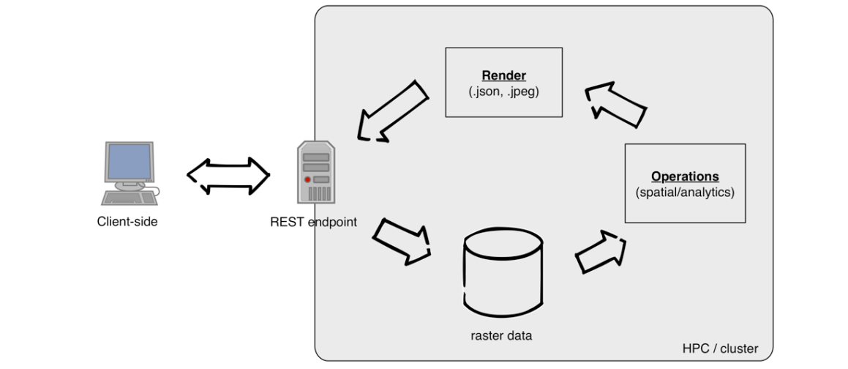
References
van Ittersum, M.K., van Bussel, L.G.J., Wolf, J., Grassini, P., van Wart, J., Guilpart, N., Claessens, L., de Groot, H., Wiebe, K., Mason-D’Croz, D., Yang, H., Boogaard, H., van Oort, P.A.J., van Loon, M.P., Saito, K., Adimo, O., Adjei-Nsiah, S., Agali, A., Bala, A., Chikowo, R., Kaizzi, K., Kouressy, M., Makoi, J.H.J.R., Ouattara, K., Tesfaye, K., Cassman, K.G., 2016. Can sub-Saharan Africa feed itself? Proceedings of the National Academy of Sciences 113, 14964-14969.
Lokers, R., Knapen, R., Janssen, S., van Randen, Y., Jansen, J., 2016. Analysis of Big Data technologies for use in agro-environmental science. Environmental Modelling & Software 84, 494-504.

