Sol Chip offers a low cost, zero maintenance, self-powering technology for automatic transmission of biophysical crop data from smallholder farms to the cloud. This technology opens new possibilities for data driven precision agriculture and large scale monitoring of smallholder agriculture.
Precision agriculture relies on the continuous monitoring of biophysical indicators of crop condition and the environment. While there has been a recent proliferation of sensors that can capture such indicators at increasingly low cost, a persistent challenge involves the collection and transmission of this data to the cloud or a centralized system, where data can be analyzed and actionable recommendations can be made and communicated to farmers. The challenge is especially acute in rural areas of developing countries, not only because of harsh environmental conditions and because of unreliable power supply, but also because of the high costs of existing solutions, which make them irrelevant for smallholder application, and the enormous difficulty of system maintenance: existing solutions are battery powered and therefore require replacement and disposal, a tremendous logistical challenge that also takes a heavy toll on the environment.
This is where Sol Chip energy harvesting technology offers a dramatic advance. Sol Chip offers a unique maintenance-free, solar powered IoT communication platform that is ideally suited for precision agriculture, as proven in pilots in Latin America. Sol Chip’s technology’s advantages include:
• Autonomous power and wireless communication (no need for external power supply)
• Supports wide variety of agricultural sensors and actuators
• Maintenance free “Everlasting battery” technology (lifetime of 10 years and more)
• Small and easy to install
• Cost effective (more than 60% cost reductions compared to existing, bulkier systems)
To date, thousands of solar chips have been installed in many different applications; the systems are deployed in the field worldwide in rough weather conditions and extreme temperature (heat wave, cold wave and extreme winter conditions) without any issues or power shortage. Solchip technology is compatible with a wide range of sensors (soil moisture or Tensiometers, water flow counters, rain gauge, PH, CO2 and many more) that can therefore provide a comprehensive picture of crop condition.

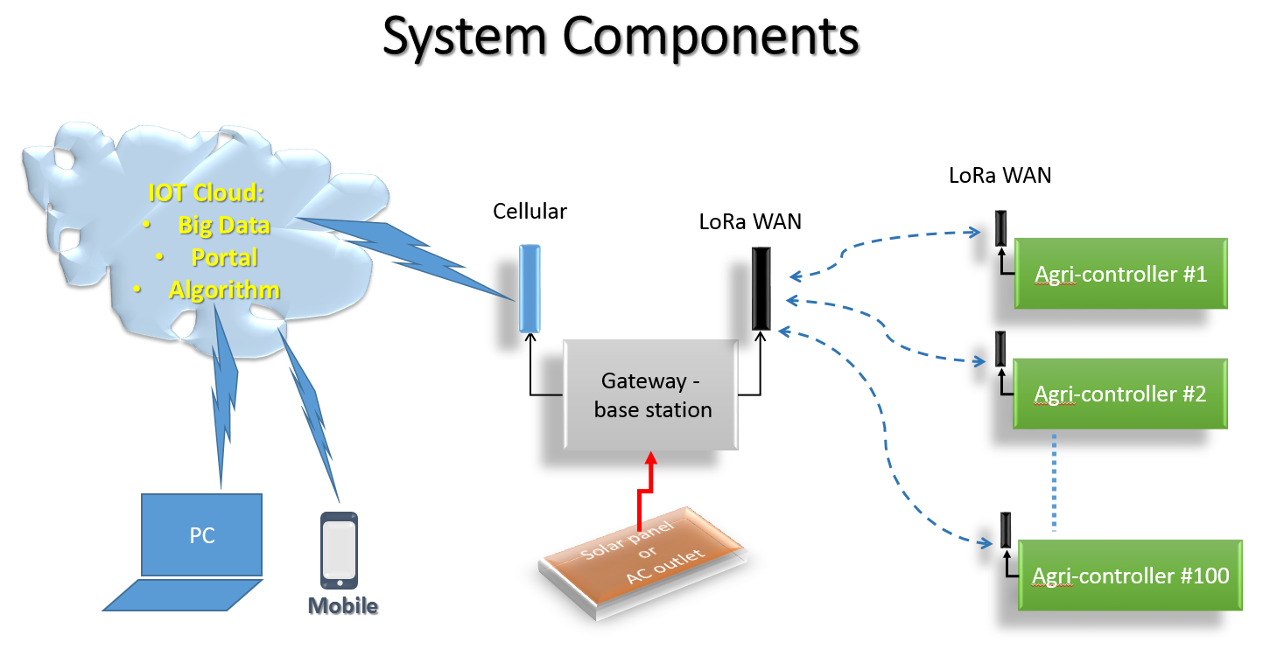
Figure 1: Each Agri-Controller activates several sensors (Analog sensors and Digital sensors such as Soil Moisture or Tensiometers, water flow counters, rain gauge, PH, CO2 and many more) and transmits their data up to the Web server through the Gateway or Base-station. The sensors data is monitored, displayed and analysed in the Web Portal and recommendation of operation is provided to the farmer. Automatic reaction is also provided as an option.
The low cost and the needlessness of maintanance of the SolChip technology open new possibilities for high quality biophysical data collection and precise monitoring of smallholder farms, even in remote rural areas of developing countries. These sensors can be installed by farmers themselves, or by public or commercial extension agents. The automatic and full proof transmission of data to the cloud enables direct and open monitoring of crop conditions without need to rely on either the farmers or extension agents to visit the sensors, read them, and share information. This data can then be used to form precise recommendations to farmers, monitor crop growth on large spatial scales, and empower unprecendeted analysis of agricultural dynamics. What is unique about the proposed solution is that for the first time, data can be collected and transmitted from thousands of nodes across large geogrpahies at low costs and unprecendented reliability without need for complex logistics.
We propose to run two yesrlong pilots, in two sites in India and in Kenya, that will demonstrate both the technical performance of the system and develop a model of farmer engagement. Sol Chip technology will be implemented on a range of sensors, including soil moisture, weather, fertilizer and pesticide concentration, of which about 100 will be installed in each site (upto 10 villages).
Intensive monitoring on the ground at the two sites will accompany biophysical sensor data with information collected from farmers in more conventional manner. This analysis will enable an exploration of the possibility of also monitoring farmers’ activities by using the biophysical data, an additional benefit with obvious benefits for monitoring and supporting smallholder agriculture. For example, high frequency monitoring of soil moisture can provide proxies of the timing and frequency of irrigation, an important aspect of smallholder behavior on which data is exceedingly scarce.
All field operations will be handled by a team of researchers and students from Tel Aviv university and researchers from our two world renowned, field implementing organizations: ICIPE in Kenya and Tata Trusts in India. The pilots will be conducted on sites in which we are already collaborating with these two partners in the field, reducing the costs required for field monitoring.
The pilots will also experiment with models of both farmer and extension agent engagement. Information collected through sensors will be communicated to farmers and extension agents employed by our partner organizations through a specially developed, simple mobile phone application as a basis for recommended farm actions. We will closely investigate and monitor the ability of both farmers and agents to make use of this information. We will also evaluate means to ensure farmers make efforts to protect the sensors installed in their farms.
Special emphasis will be made on finding integrated models of utilizing the system for maximum impacts at minimal cost. For example, since sensors and Sol Chip technology are highly mobile, to maximize the coverage of each sensor, we will experiment with a model in which extension agents move the unit across different locations (farms) in a rotation system.
Both pilots will run for an annual agricultural cycle. The expected costs of the pilot include the costs of the technology itself (estimated at USD 35,000 in each site), the development of the app (USD 5,000) and the costs of field work, experimental design and analysis (USD 25,000).

