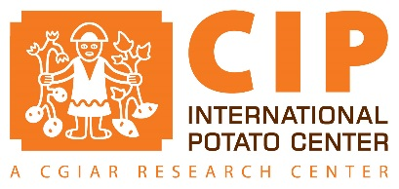
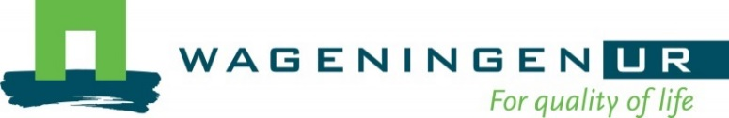

What is your idea?

Potato late blight (LB) is one of the world’s most important food-crop diseases with global annual losses estimated to be between US$3 and 15 billion. LB is weather dependent: humidity and temperature affects its development, and rainfall affects fungicide efficacy. Fungicides are the preferred control method and, in developed countries, sprays are scheduled following recommendations generated by decision support systems, which use disease outbreak and weather data as input variables. In developing countries, lack of affordable weather stations and extreme environmental variability (e.g., the Andes), have precluded the use of such decision support systems. As result, fungicide use in developing countries is far from optimal causing severe health damages to farmers, as documented extensively by CIP.

We propose to develop a platform for LB disease warning and management. A network of young farmers and extension agents will scout for early attacks of LB and provide local weather data, using a new generation of cheap and reliable sensors, to create big data related to LB management. The collection of real-time observations of disease outbreak, locally registered weather data and locally implemented management practices will allow using decision support systems which, through crowdsourcing and citizen science, will help farmers to optimize LB control at large scale.

We will apply cutting edge tools and approaches (nano sensors, crowdsourcing and citizen science) to deal with an old and recalcitrant problem on LB management: over use of fungicides. Our hypothesis is that farmers will improve LB management by having access to sophisticated decision support systems, which require local weather data and information on disease outbreaks. By creating a farmer research network focusing on young individuals, we hypothesize that we will create social capital to encourage them to stay in the field, become better farmers, and try new technologies. This network will help to speed up the process of testing and dissemination of new technologies.

How will you pilot it?

Activity 1 (sensor selection). We will identify weather sensors that can be connected to mobile phones and that can work in field conditions. These sensors will be tested under farmers’ conditions to estimate their accuracy, precision and robustness. At least one weather sensor will be selected.

Activity 2 (digital platform development). We will create an app for mobile phones. This app will allow young farmers to connect to weather sensors and record disease pressure and management practices to control LB. This app will also allow sharing data with other members of the network and, more importantly, will generate a recommendation using a decision support system previously identified by our team. The app will be developed and tested with farmers in iterative cycles. The digital platform will also include software to manage data and generate recommendations at a landscape scale.

Activity 3 (network creation). We will identify a geographical area in the highlands of Peru where LB is a major problem. We will then identify local partners that have close connections with young farmers, such as local colegios agropecuarios. Using a highly interactive methodology (FFS with a twist for the digital era) we will engage with them to learn how to install the weather sensors, use the app, and record the information. We will also work with them on the basics of late blight control, using well-tested training materials. We expect that in first year at least 100 young farmers become members of the network.

Activity 4 (running the network). Young farmers will test the recommendations given by the decision support system in their fields. Twenty to 30 potato fields will be selected at random and will be divided in two halves each: one will be managed using the decision support system, and the other one using current practices. Field days will be organized to compare and discuss the results.

Data generated in the first year will include: performance of weather sensors at field level; temperature, relative humidity and rainfall data at landscape scale; recommendations for LB management and current practices at landscape scale.

Next steps will include defining the scaling readiness of this technology (in collaboration with RTB cluster 5.4), and scaling the technology (in collaboration with the RTB scaling fund – proposal in preparation).

RTB cluster 5.4 is estimating the scaling readiness of a decision support system that does not require data from weather stations. In the current proposal, we are aiming at reaching young farmers who are keen on using mobile apps and testing new ideas.

