What is your idea?
The main goal is to evaluate the sustainability of production landscapes where agricultural commodities for export threaten pristine forest cover in the tropics. The pilot study will be conducted in cocoa production areas of West Africa, where our team already has established contact with the private sector, with the aim to build a prototype land-management tool based on robust predictive spatio-temporal models and big earth observation data analytics.
Why is the idea an unconventional or creative approach to the problem outlined in the topic?
Most of current experiences in land monitoring have focused separately on natural vegetation and agricultural cover. None of these experiences has attempted to combine both layers of information using a coherent and scalable approach for producing a reliable land management tool for the state and private sector. For instance, most of forest changes attributed to specific agriculture drivers (i.e. commodities for export such as oil palm, cocoa, livestock) are mainly based on reports by the media or studies with high cost and time investments conducted at local scales. Moreover, whilst recent research shows small and medium farms (≤50 ha) produce up to 77% of almost all agricultural commodities, it remains unclear to what extent these systems are responsible for forest loss. Additionally, although commodity moratoriums have been implemented to reduce the impact of large scale plantations on deforestation, there are still problems tracking these changes.
Taking advantage of the flourishing growth of accessible satellite and auxiliary data for agricultural and environmental research, the proposed approach aims to use robust predictive spatio-temporal models and big earth observation data analytics to fully exploit and automate the discovery of patterns from both data sources to reveal the sustainability of agriculture commodities for export, according to their impact on pantropical forest change.
- Describe the hypothesis for the proposal and why it is expected to succeed.
H1: Agricultural commodities for export (e.g. cocoa, oil palm) which are triggering environmental harm, in particular forest loss in tropics, can be identified and monitored by robust predictive models capable of fully exploiting large volumes of raw earth observation time series and ancillary data.
H2: The use of big data technologies and maximization of computer resources provide efficient and promising results for the scalability of the proposed models.
The project is expected to succeed because:
- The implementation of the proposed models will be coupled with an existing big data pipeline (Hadoop/Spark) developed by the team for ingesting, storing and processing large volumes of geospatial data, including satellite data.
- The user-oriented outputs will support 1) the current efforts by international organizations such as CGIAR and nations to produce base information for reducing deforestation, estimating carbon emissions and monitoring forest change associated land tenure; and 2) the needs of producers and buyers for scalable tools to assess environmental impacts of cash crop production and identify the most important environmental and climate change i.e. carbon footprint friendly farming systems.
- The team has participated in multiple projects in collaboration with CGIAR centers, including the successful implementation in collaboration with CIAT of the Terra-i system.
How will you pilot it?

Describe the implementation plan, including any new technologies or tools that will be developed.
The implementation plan will consist of six milestones (M):
M1. Collection and processing of available cocoa crop plantations data.
M2. Integration of satellite data (MODIS, Landsat8, Sentinel, etc) into the Big data platform.
M3. Development of robust Machine Learning models of cash crop vegetation dynamics and spatial pattern matching, to enhance the algorithms for anomaly detection.
M4. Implementation of proposed model and analysis of the outputs.
M5. Implementation of visualization interfaces to share and facilitate the analysis of resulting data.
M6. Dissemination and feedback of the prototype of land-management tool to public and private sector (e.g. Swiss Platform for Sustainable Cocoa).
- Explain how the work will be performed within the budget (USD$100,000) and time (12 months) allowed?
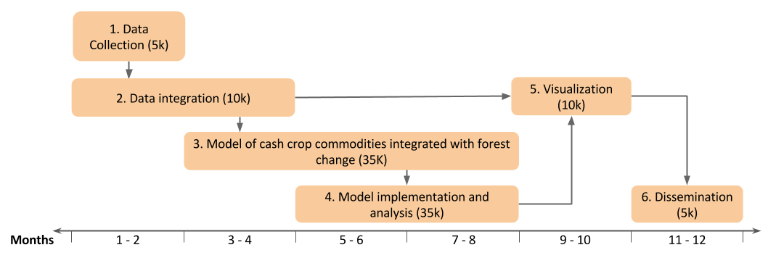
- What essential data will be generated during this pilot?
Output 1 – Data of anomaly detection (forest change) related cash crop identification ready to be used.
Output 2 – Identified and characterization of hotspots with probabilities of the most likely crop/land use after deforestation.
Output 3 – Information on the produced data and reports of case studies in visualization tools.

If the pilot is successful, what are the next steps?
The next steps will be to extend the methodological framework at pantropical scale, in particular targeting nations where other agricultural commodities systems are also key subjects of concern by the public and private sector. To increase the chance of expanding the tool, it is expected that the tested framework is introduced to international initiatives such as the UNDP’s Green Commodities Programme. So far this program, launched in 2009, is already involved in transforming the production and supply chain of seven highly traded commodities that have significant political influence and the potential to impact millions of farmers in the countries where the program works.

